RECIPE  
Easy Chicken Ramen

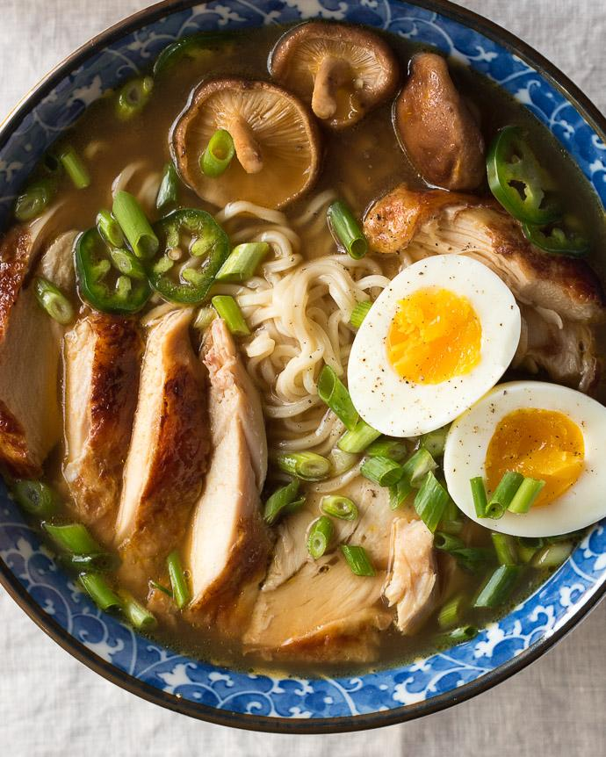

# Ingredients

* 2 Chicken Breasts
* Kosher Salt and freshly-ground black pepper to season
* 1 tbsp unsalted butter
* 2 tsp sesame oil
* 2 tsp fresh ginger, minced
* 3 tsp fresh garlic, minced
* 3 tbsp low-sodium soy sauce
* 2 tbsp mirin
* 4 cups rich chicken stock
* 1 oz dried shiitake mushrooms (or ½ cup fresh)
* 2 large eggs
* ½ cup Scallions, sliced
* 2 (3oz) packs ramen
* Optional: fresh jalapeno slices, for serving

# Preparation

1. Cook the chicken * : Preheat the oven to 375 degrees. Season the chicken generously with salt and pepper. Melt the butter in a large oven-safe skillet over medium heat. Add the chicken, cook until golden brown and it releases easily from the pan about 5-7 minutes. Flip the chicken and cook for another 4-5 minutes, and transfer the skillet to the oven to roast for 15-20 minutes until the chicken is cooked through.
2. Make the ramen broth: Heat the oil in a large pot over medium heat,until shimmering. Add the garlic and the ginger, and cook for a few minutes until softened. Add the soy sauce and mirin, and stir to combine. Cook for another minute. Add the stock, cover, and bring to a boil. Remove the lid, and let simmer uncovered for another 10 minutes, and season with salt, to taste.
3. Make the soft-boiled eggs. Fill a pot with enough water to cover the eggs, and bring to a boil. Gently lower the eggs (still cold from the fridge) into the boiling water and let simmer for 7 minutes for a slightly runny yolk.
4. Meanwhile, fill a large bowl with ice water. When the timer finishes, transfer the eggs to the ice bath. Peel the eggs and set aside until ready to serve.
5. Assemble the bowl: Chop up the scallions and jalapenos if desired. Set aside and boil the noodles until soft. Divide the noodles into bowls and add broth, sliced chicken, scallions, jalapenos, and eggs.